**Whitney M. Young Prek-8**

**Staff Handbook**



**2024-2025 School Year**

# CONTACT INFORMATION

## School Information

**Address:**

17900 Harvard Ave

Cleveland, Ohio 44128

**Main Office:**

216-838-5350

***Carlisha Bias, Principal***

Cell: 216-402-3110

Carlisha.Bias@clevelandmetroschools.org

***Nicole Dykstra, Assistant Principal***

Cell: 216-212-8868

Nicole.Dykstra@clevelandmetroschools.org

***Frederick Mcfarland, Dean of Engagement***

Cell: 330-631-2373

Frederick.mcfarland@clevelandmetroschools.org

# STAFF LIST 2024-2025

**Title Name**

Principal Carlisha Bias

Assistant Principal Nicole Dykstra

Dean of Engagement Frederick Mcfarland

School Office Manager Stephanie Allen

Security

Nurse Tamika Smith

Psychologist Julie Wocjcik

Occupational Therapist Ellen Bartz

Speech Therapist Zoe Eilbeck/Hannah Klein

Head Custodian Justin Steward

Environmental Service Specialist Anna Delaney

Lunch Room Manager Sonseeahray Powell

Model Lead Teacher Virginia Kresak

Pre-K Sara Bobay

Paraprofessional Pre-K Yolanda Conner

Kindergarten Laura Gladin

Paraprofessional (Aut/Md) Rhonda Hardin

First Grade Morgan Saunders

First Grade Lori Evans

Second Grade Shantae Lipscomb

Special Education K-2nd (Aut/Md) Carmen Woody

Third Grade Jarita Roundtree

Paraprofessional (Aut/Md) Malinda Coleman

Structured Reading Specialist Arlisa Fountain

Fourth Grade Edward Kmitt

Intervention Specialist (Cd) 3-5 Michelle Perry

Intervention Specialist (Aut/Md) Karen Smith

Intervention Specialist (Cd) k-2 Carolyn Mcbee

Intervention Specialist Kimberly Shemo

Fifth Grade Richard Sullivan

Intervention Specialist (Cd) 6-8 Matthew Pope

Intervention Specialist 6-8 Tracey Alexander

Paraprofessional (Aut/Md) Tamika Mckinley

Science Middle School Ryan McFeely

ELA Middle School Lindsey Moomaw

Math Middle School Jennifer Cummings

Intervention Specialist (Aut/Md) Jennifer Walker

Intervention Specialist (CD/CC) Christopher Kraska

Paraprofessional (Aut/MD) Melissa Torres

Physical Education Teacher Joseph Marshal

Art Teacher David Kuss

Music Teacher James Fair

Media Specialist (Part Time) Naimah Gooden

PCIA Syretta Taylor

Say Yes Family Support Specialist Nicole Washington

Parent Ambassador Eric Odell

Community, College, Career Center Coor. Marshanta Talley

Life Solutions Psychologist Dr. Deborah Watson

Life Solutions Counselor TBD

Cleveland Playhouse Coordinator Jonathan Sweet

# ROOM NUMBER ASSIGNMENTS

|  |  |  |  |
| --- | --- | --- | --- |
| **Teacher Name** | **Grade/Role** | **Extension Number** | **Room Number** |
| Justin Steward | Custodian | 85355 | 103A |
| James Fair | Music Teacher | 85387 | 104 |
| Eric Odell | Parent Ambassador | 85386 | 105 |
| Nicole Washington | Say Yes Coordinator | 85386 | 105 |
| Dr. Julie Wojcik | Psychologist | 85385 | 106 |
| Cory Vaughn | Psychologist | 85385 | 106 |
| Joseph Marshall | Physical Education Teacher | 84434 | 107 |
| David Kuss | Art Teacher | 85374 | 111 |
| Carolyn McBee | Intervention Specialist | 85376 | 112 |
| Stephanie Allen | Office Manager | 5350 | Office |
| Malinda Coleman | Paraprofessional (AUD/MD) | 85379 | 114 |
| Karen Smith | Intervention Specialist  (AUD/MD 3-5) | 85379 | 114 |
| Edward Kmitt | Fourth Grade Teacher | 85382 | 116 |
| Jarita Roundtree | Third Grade Teacher | 85380 | 117 |
| Virgina Kresak | Model Lead Teacher | 85378 | 118 |
| Arlisa Fountain | Structured Literacy Specialist | 86376 | 118 |
| Richard Sullivan | Fifth Grade Teacher | 85377 | 119 |
| Michele Perry | Intervention Specialist | 85375 | 120 |
| Kimberly Shemo | Intervention Specialist | 85375 | 120 |
| Naimah Gooden | Media Specialist | 85371 | 127 |
| Marshanta Talley | CCCCC | 85371 | 127 |
|  | Security Office | 85373 | 128 |
| Laura Gladin | Kindergarten Teacher | 85370 | 129 |
| Sara Bobay | PreK Teacher | 85361 | 130 |
| Yolanda Conner | Paraprofessional PreK | 85361 | 130 |
| OPEN |  | 85632 | 131 |
| Lori Evans | First Grade | 85364 | 132 |
| Ellen Bartz | Occupational Therapist | 85366 | 134 |
| Zoe Eillbeck | Speech Therapist | 85366 | 134 |
| Hannah Klein | Speech Therapist | 85366 | 134 |
| Sensory Room |  | 85366 | 134 |
| Shantae Lipscomb | Second Grade | 85369 | 135 |
| Morgan Saunders | First Grade | 85368 | 136 |
| Carmen Woody | Intervention Specialist (K-2 AUT/MD) | 85367 | 137 |
| Rhonda Hardin | Paraprofessional (K-2 AUT/MD) | 85367 | 137 |
| Melissa Torres | Paraprofessional (K-2 AUT/MD) | 85367 | 137 |
| Life Solutions | Mental Health provider | 85363 | 141 |
| Carlisha Bias | Principal | 85352 | 144L |
| Tamkia Smith | Nurse | 85357 | 144B |
| Ryan McFeely | MS Science and MS 8th Grade Social Studies | 85397 | 203 |
| Tracey Alexander | Intervention Specialists 6-8 Self-Contained | 85399 | 204 |
| Tamika McKinley | Paraprofessional6-8 Self-Contained | 85395 | 204 |
| Christopher Kraska | Intervention Specialist (CD/CC) | 82691 | 205 |
| Matthew Pope | Intervention Specialist | 82693 | 207 |
| Jennifer Walker | Intervention Specialist | 82693 | 207 |
| Syretta Taylor | Planning Center | 85381 | 208 |
| Nicole Dykstra | Assistant Principal | 85395 | 209 |
| Jennifer Cummings | MS Math and 6th Grade Social Studies | 82690 | 210 |
| Lindsey Moomaw | MS ELA and 7th Grade Social Studies | 85396 | 211 |
| Frederick McFarland | Dean of Engagement | 85356 | 212 |

# MISSION AND VISION

## Mission Statement:

Whitney M. Young PreK-8 School provides a nurturing environment committed to achieving excellence. All students are challenged to reach their maximum potential by learning at their functional level. Students will explore, discover, learn, create, and reflect, on or above grade level, to prepare them to be productive, well-educated citizens and cope with the ever-changing world.

## Vision for Whitney M. Young:

"If we use the Personalized Learning Model with fidelity, provide high quality professional development, deliver effective rounds of coaching on best practices with accountability, and successfully access online and blended learning techniques; the achievement of our Whitney Young scholars will increase”

## Whitney M Young Creed

We are Whitney M. Young

We believe in ourselves

We strive to be excellent

We never give up on our dreams

We will become successful in life

We are strong and courageous

We are hard working

We respect ourselves and others

We are life-long learners

We are the Warriors

(Students will recite the creed each morning during announcements. Practice the Creed with your students and take time during morning meetings to discuss why the words are important).

## Warrior Behavior Expectations/Matrix

How to be a Warrior

W- work together: help others, share and take turns!

A- academic mindset; come prepared to learn each day!

R- respect is key: follow adult directions the first time, use kind words!

R- remain safe: keep hands, feet and all objects to yourself, use walking feet!

I- integrity: be trustworthy, follow the rules because it’s the right thing to do!

O- own your actions: take accountability for your own actions!!

R- responsibility: clean up after yourself, take care of school property!

## PBIS Warriors are: BRAVE!!!

**B**e Responsible!

**R**espect each Other!

**A**cademic Mindset!

**V**alue Differences!

**E**veryone can Succeed!

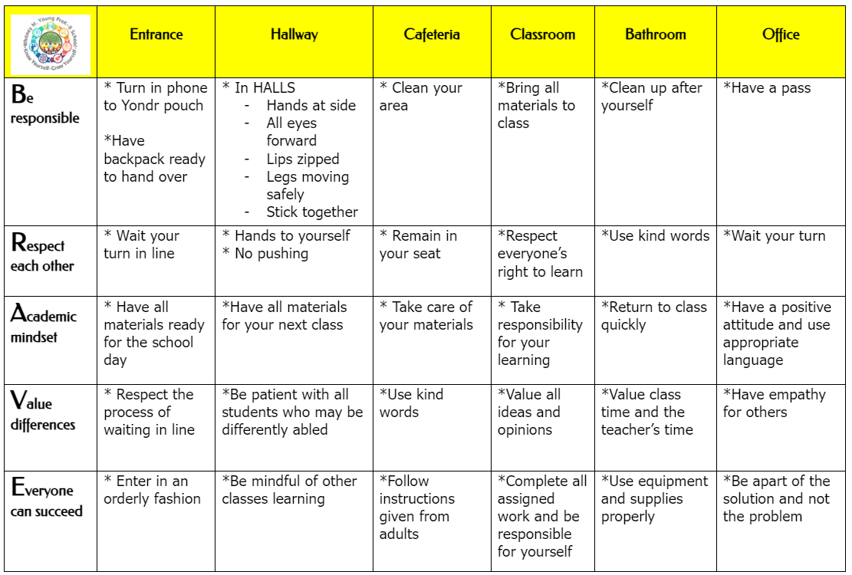

# 

# 

# BUILDING PROCEDURES

## Arrival Procedures (doors open at 7:15am)

* During arrival, the safety and security officer’s primary functions are outlined below.
  + Checking bookbags (students need to unzip book bags to make the process go faster
  + Facilitating the metal detectors
  + Admin assigned outside to monitor line
* After passing through the metal detectors, each student in grades kindergarten through eighth will hand their cell phone to an adult staff member to place in the Yonder pouch. Each student will receive a school-provided Yonder pouch (property of Whitney M. Young). After the pouch has been locked by the adult staff member, the pouch (with the cell phone inside of it) will be returned to the scholar before entering the atrium of the school.
* Parent drop off for pre-kindergarten will occur in the front. Parents will sign the sign sheet and paraprofessional/staff will escort students to the classroom. Parent drop off for k-8 will occur in the front parking lot.
* Security will ensure that parents are escorted directly to the side office door, to officially sign and make an appointment.

## Hall Expectations

All students in grades prek-8 will follow the same hallway procedure with the following HALLS acronym:

H- Hands to your side

A- All Eyes Forward

L- Lips Zipped

L- Legs Moving Safely

S- Stick Together

HALLS should be practiced often with your class. Practice with feedback is the most effective way to uphold hallway best practices. The admin will check classes for HALLS and will monitor daily. Compliments will be given to classes demonstrating effective Hallway Behavior. Classrooms who receive 10 compliments in a month will receive a special incentive for modeling the expectation provided by the teacher. (Incentives could include; extra recess, movie time, free time…)

## Bathroom Break Assignments

* Classrooms with restrooms in the room will use their restrooms. All classrooms are listed to provide a cleaning schedule for the custodians.

|  |  |  |  |
| --- | --- | --- | --- |
| **Teacher/Grade** | **Assigned Restroom** | **Morning Break Time** | **Afternoon Break Time** |
| Kraska | In classroom | 8:30-8:45 | 12:00-12:15 |
| Bobay | In classroom | 8:30-8:45 | 12:00-12:15 |
| Gladin K | First Floor | 8:00-8:15 | 12:25-12:40 |
| Walker K | First Floor | 8:15-8:30 | 12:25-12:40 |
| Saunders 1st | First Floor | 8:30-8:45 | 1:15-1:30 |
| Evans 1st | First Floor | 8:45-9:00 | 1:15-1:30 |
| Roundtree 3rd | First Floor | 9:00-9:15 | 1:30-1:45 |
| Lipscomb 2nd | First Floor | 9:15-9:30 | 1:30-1:45 |
| Kmitt 4th | First Floor | 9:30-9:45 | 12:40-12:55 |
| Sullivan 5th | First Floor | 9:45-10:00 | 12:55-1:05 |
| McFeely | Second Floor | 8:30-8:45 | 12:25-12:40 |
| Cummings | Second Floor | 8:45-9:00 | 12:40-12:55 |
| Moomaw | Second Floor | 9:00-9:15 | 12:55-1:10 |
| Alexander | Second Floor | 9:15-9:30 | 1:10-1:25 |
| Kraska | Second Floor | 9:30-9:45 | 1:25-1:40 |

## 

## Bathroom Procedures

* Use the assigned restroom break times to ensure minimal interaction between scholars
* Adhere to the maximum capacity limits set for each restroom.
* Determine method of communication or signal for knowing whether this threshold has been met (e.g. badge on hook)
* Students must wash their hands using either cold or hot water and soap or using hand sanitizer.
* If the students must use a shared bathroom in the hallway, be sure to avoid using the stalls next to each other and be sure to avoid having students use sinks side by side. All staff and students should still follow the hand washing guidelines provided.
* Bathroom passes should ONLY be given in emergency situations; at which point, the teacher needs to call the office to ensure that administration is aware that a student is out of the classroom for too long.

## Middle School Bathroom Procedures

* If the homeroom teachers choose not to use the full class restroom breaks, the following procedures are to be taken:
* Practice a non verbal signal that asks for permission to use the restroom
* Teacher will then acknowledge student and grant permission to leave the classroom
* Middle school scholar must sign out with a time and take the restroom pass to leave the class
* Scholar will then return and sign back into the classroom with the time and return the pass back to its designated location
* Middle school scholars are not allowed to use the first floor restrooms.

## Lockers

* Lockers will be assigned to each middle school scholar. Teachers and administrators will schedule times to practice unlocking with assigned combinations and effective use of the locker.
* Lockers are NOT to be shared between scholars. Each scholar will have their own locker assigned to them and will be provided ample time to practice during week one of school.
* The admin offices on the second floor will NOT be used for storing scholar’s items.

## Cell Phones

* During day one of the 2023-2024 school year,, Whitney M Young has adopted a new cell phone policy and invested in the Yondr Pouches for all scholars in grades three through eight. This is a school property that is being provided to each scholar at the beginning of the day.
* When scholars enter the building at the beginning of the day, after going through the metal detectors, they will hand their cell phones (which are turned off) to a staff member. The staff member will place the cell phone in a pouch that is labeled for each student. The pouch will then be locked and returned to each scholar. The scholar can either keep their pouch with them or place it in their locker or cubby.
* Prior to leaving the building at the conclusion of the day, a staff member will come to grades three, four and five to open the locked pouches, return the turned off cell phone and keep the pouches.
* For grades sixth through eight, scholars will dismiss by class into the second floor main hallway at specified times at the top of the stairwell by the double doors. At this time, each scholar will have their pouch unlocked for them by an administrator prior to receiving their cell phone back. The pouch (as it is Whitney M. Young property) will stay at the school until the next morning.
* If scholars dismiss early from school, they will have their pouch unlocked in the main office. The pouch will remain at the school while the cell phone goes home with the student.
* In case of an emergency:

1. Each classroom is equipped with a landline phone.
2. Additionally, parents may contact the main office at 216-838-5350 for a message to be relayed to the appropriate scholar or reach out to the classroom teacher through Class Dojo or email.
3. Scholars are permitted to use the main office phone or the class phone if given permission (and a note in the case of using the main office phone) to call home during lunch or recess.

## Transitions Procedures

* Middle school students will be able to check lockers during transitions. Lines are expected to maintain order. They have three minutes between each class to do so. A bell system is used to assist scholars in identifying how much time they have remaining.
* Teachers will transition their scholars to each encore class as well as lunch
* If encore teachers have a class right after recess/lunch the encore teacher is responsible for picking up their students
* Middle school teachers are expected to be at their classroom threshold door to ensure a smooth transition
* HALLS will be used during all transitions.
* Admin or security will be present during the transitions.
* Entering/Exiting Classrooms or Offices
  + Students must enter one student at time when entering or exiting a classroom or office
  + If someone is entering or exiting at the same time, stand outside of the door frame and allow the other person to pass.
  + When possible, identify one door for entering and one door for exiting
  + Schools should determine how many people can safely fit in the office

## Dismissal Procedures

* Dismissal groups include the following: prek-kindergarten/ Car Riders 1-4/Car Riders 5-8/Bus Riders(Van Riders)/Walkers

|  |  |  |  |  |
| --- | --- | --- | --- | --- |
| **Group** | **Location** | **Time** | **Procedure** | **Paraprofessional Duty** |
| Prek  Kindergarten | Cafeteria/Side Door  Side gym door | 1:45 | Students will be dismissed from the cafeteria.. Parents will walk up to the door to sign students out. | Ensure that students are released to verified adults. |
| Car Riders | Waiting area: Outside; Side of building  Pick-up area: Side parking lot, along the black fence.. | Called to location at 1:50.  Dismissal will begin at 1:55. | Students who are being picked up MUST be escorted by teachers to the side parking lot.  First 2 weeks, each teacher will have a paper for parents to sign indicating vehicle make/model and adult(s) who are responsible for pickup. | Admin/para will monitor lines outside. We need staff to ensure that students get to vehicles safely.  Students are not to go on the playground during dismissal. |
| Bus Riders | Waiting area: In the front parking lot.  Pick-up area:  Front Parking lot | Called to location at 1:50.  Dismissal will begin at 1:55. | Teachers will escort students and wait in assigned areas outside according to their bus number. | Admin/para will monitor lines outside. We will also need staff to ensure that students get on the bus safely. |
| Walkers | Front entrance | 1:55 | As students transition, only verified walkers will be allowed to walk out the front door.  (Middle school will use back door) | Monitor families if they have younger siblings, to ensure they meet up and start walking home. |
| Middle School | Back door in main hallway | 2:00 | Middle school scholars must be escorted until they are off of the property.  Middle school scholars will also have to check out their phone via administrator with the Yondr Pouches | Ensure that middle school scholars make it off of school property. |
| Late Pickups | Cafeteria | After School | If students are not picked up on time; students will assemble in the main office and phone calls will be made. If parents are drastically late several times in a row, they must have a meeting with the principal. | Paras will monitor students waiting and assist Allen in making phone calls to parents. |

## Students are not to be on the playground during dismissal.

## 

## After School Programming

CPH will be offered for k-8 (contact Mr. Sweet updates with enrollment)

Only registered students may attend

Staff must take attendance daily

## 

## Early Pick-up Policy

Parents/guardians/caregivers must call the office to make an appointment for an early pickup. A solid reason (emergency) must be provided. After the parent signs the student out,the student will be called down to the office. Parents will not be permitted to go through the building to get students from classrooms. If early pick-ups, without a solid reasoning, become a trend, the parents must have a meeting with the principal or member of the admin team. Early pick up concludes at 1:30pm.

## Attendance

* Attendance is expected to be taken at 8:00 am through PowerSchool. Contact Ms. Allen in the main office if there is an issue .

# WARRIOR CAFE

## Breakfast

* Students will eat breakfast in the cafeteria from 7:15-7:35
* All students will remain in the cafeteria until 7:35
* Late arrivals: If students arrive late, after breakfast has been served; they will get a pass and eat in the cafeteria to eat, if they want a breakfast
* Custodial staff will have a cleaning routine to collect trash after breakfast
* Teachers are expected to pick up their class each morning at 7:35 from the cafeteria

## Lunch Expectations

5 Lunch Expectations:

* Stay in your seats (four per bench seat) (2 per side of each bench)
* Talk at a voice level 2
* Keep your hands to yourself
* Keep your area clean
* Raise your hand if you need an adult
* Each table will be dismissed by a staff member after the scholars have cleaned up their trash
* Students will not be able to transition until they clean up their area

Students will transition to the door of the cafeteria (Warrior Cafe). Students will go directly to the line and sit at their assigned areas. Students will be expected to follow the expectations.

## Lunch Consequences

Step 1- Verbal Warning

Step 2- Seat Change

Step 3- Phone Call Home

## Lunch Detentions

Teachers are required to contact parents if/when a detention is issued to a student to share the reasoning behind detention and for support. Kuss will collect detention students each day. No more than 15 students can be placed in lunch detention in one day. Detention must be entered the day before. Sign up sheet will be placed in the main office.

Custodial staff will create a system of the daily clean up procedure after lunches.

## Recess

* Whenever reasonably possible, recess should be held outside
* Indoor recess will take place in the gymnasium.
* Gym equipment can be shared between students. This includes playground equipment [i.e. balls, jump ropes, etc. ]
* Possible settings: playground, field
* Preschool: Students may participate in recess following the guidelines provided. If hands are visibly dirty, they must be washed and cannot use hand sanitizer for deeper cleaning. Pre K students will use the back playground for recess.

# EMERGENCY DRILLS

## Fire Drill Procedures

* Building fire alarms must be tested prior to students re-entering the buildings to ensure that they are fully functional and audible
* A fire evacuation drill must be conducted during the first 10 days
* Bi monthly fire evacuation drills will resume
* All other drills will need to be conducted as scheduled (code blue, red, tornado) as required
* Each classroom must exit out door closest to their classroom
* Students must travel off of school grounds (sidewalks)
* Students will remain silent until drill is over
* Administration will give an all clear when the building is clear and all procedures have been met.
* Time will be recorded by Allen and the security team.
* Teachers and staff will review the procedures (how to correctly exit the building and return) with students during the first week of school.

## Tentative Fire Drill Schedule

The first or second Wednesday of each month. Only administrators, custodial team and security will have access to agreed upon times. Teachers/students will have to conduct the drills at unexpected times. Teachers are to lead students out the nearest exit and proceed outside to line up on Harvard. Students are to remain silent during the drill. All teachers should bring out his/her rooster and give a thumbs up when all students are counted. Admin will the “all clear” after drill is over and students will assemble back into the building.

Wednesday August 21

Wednesday September 4

Wednesday October 9

Wednesday November 6

Wednesday December 4

Wednesday January 15

Wednesday February 12

Wednesday March 5

Wednesday April 2

Wednesday May 7

**Code Blue/Red/Tornado Drills**

We will follow the emergency procedures with the code blue, code red, and tornado expectations throughout the school year .

# CULTURE AND DISCIPLINE

## Warrior Behavior Chart

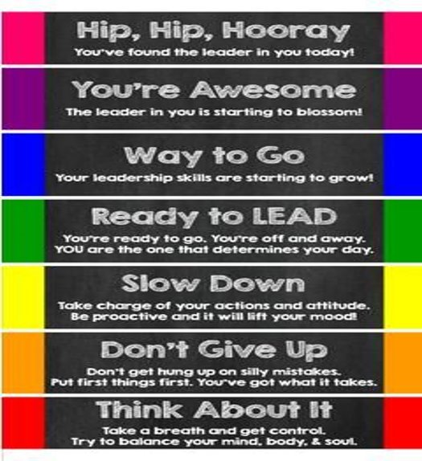

In order to have the same language throughout the building, Whitney M. Young prek-8 will be implementing a Warrior Behavior Chart to be used throughout the day. Students will be able to travel up and down the chart depending on their behavior. If a student lands on red and his/her behavior changes in a positive way, they can travel back up the chart. Each student will start on green at the beginning of each day.

Grade band teams will decide on fair, equitable, best practices that will move students up or down the Warrior behavior chart.

Each teacher will receive a chart for their classroom and a yard stick with the specific colored tape from the chart. Each class will also receive clips for student names. At the end of the day. Students will receive a certain amount of dojo points for the color they earned for the day.

## Classroom Dojo

The Dojo application will be one of our primary tools used for incentives. Each teacher should have a Dojo set up in Whitney M. Young prek-8. Point system is at the teacher's discretion.

* Pink- 5 dojo points (If a scholar lands on pink, they can receive a positive phone call home, a Warrior shoutout for academic mindset, or small prize from teacher)
* Purple- 3 dojo points
* Blue- 2 dojo points
* Green- 1 dojo points
* Yellow- 0 dojo points
* Orange- 0 dojo points
* Red - 0 dojo points

## Office Referrals

When the office referral is filled out, the teacher is encouraged to call the office to let the admin team know that an office referral has been assigned. At this point, the student is to wait in the classroom (if possible) until an escort is there to collect the student and transition to the next stop. Escorts could include: Officer (security), McFarland (Dean of Engagement), Dykstra (Assistant principal), Bias (principal). The goal is to reset the student effectively so that they are prepared to return to class with the least amount of instructional time lost as possible. Other students are not to escort referred students down to the office without it being approved by the admin team. The admin team will review the referral and determine the best way to reset the scholar. Students will be automatically removed if there is a violent/safety issue and the teacher can fill out a referral by the end of the day.

## Walkouts

If a student walks out of class without your permission, immediately contact the office so that we can locate said student, reset them, and return the student back to class. It is your responsibility to call until you reach a staff member in the office or an administrator. If there is no answer, send a scholar.

Chronic walkouts may require planning center, detention, suspension, parent conference, referral…

## Dress Code

Whitney M. Young prek-8 students are not required to wear uniforms.

Cleveland Metropolitan School District Educationally Appropriate Dress and Appearance/Dress Expectations

The responsibility for the dress and appearance of a student rests primarily with the student and their parents or guardians. In the interest of maintaining a safe and healthy learning environment, the district believes in the following basic principles:

All students are required to dress in a manner that is appropriate, comfortable and conducive to an active academic school day.

• Students should be able to wear clothing without fear of or actual unnecessary discipline or body shaming.

• The student dress code should serve to support all students to develop a body-positive self image.

• The district standard dress and appearance policy is gender neutral and applies to all students equally regardless of gender on school campuses and at school-sponsored functions and will be enforced consistently and fairly by all members of the school staff.

Examples of inappropriate clothing include:

• clothing where the buttocks or torso is exposed, i.e., tube tops, half shirts, halters • clothing that is see-through. (clothing must be opaque) • clothing or accessories that show profanity, obscene words or pictures, sexually suggestive statements, violence, or incitement to violence • clothing representing gang-related activities • clothing where the entire thigh is exposed, such as micro minis or short shorts. • bathing suits or cut-offs • the wearing and carrying of tobacco promotional items, or items promoting controlled substances (drugs) and/or alcohol • clothing where undergarments are exposed • clothing that has text or visual images that is libelous, bullying, constitutes harassment or discrimination • footwear must be worn at school and all functions • no backless or open toe footwear

Additionally, site leadership (UCC subcommittee plus one parent) with a survey from parents, may establish a site-specific dress code addendum in the following circumstances:

A. Times when students are engaged in extracurricular or other special school activities and where the standard dress and appearance policy would not be appropriate for the activity.

B. Times when students are engaged in specific courses where modification is needed to ensure the safety of the students engaged in the class. Examples include lab sciences, physical education, CTE classes or other classes that contain potential hazards.

C. Schools may set their own site-specific addendum relating to hats, caps and other head coverings. There shall be no restriction on student head coverings worn for bona fide religious purposes.

D. Each school site, in accordance with the District Dress Code Review Process (as directed by Dress Code Committee, which meets once a semester) may develop additional guidelines stricter than the district's minimum standard dress and appearance policy; however, these site-specific dress code addendums may not contradict the district’s dress and appearance policy outlined in this document. Schools are responsible for following the identified district policies on notification of students and parents for their site-specific addendums.

Consequences of Dress and Appearance Code Violations Dress and appearance code violations will have consequences that are applied consistently and equitably. Except under exigent circumstances, suspension or expulsion will not be used as a consequence for the violation of a dress code. Site Staff shall provide students an opportunity to remedy the violation. Opportunities to remediate may include, but are not limited to, parental contact, offer of exchange of clothing, referral to the Student Support Team (SST), or to the Say Yes Coordinator. Any discipline that shall arise out of dress code violations shall have minimal loss of instructional time as its goal.

First Violation: Administrator, or designee (not a CTU member), can make a parent/guardian call. Students will be offered the opportunity to remedy the situation, which could include an exchange of clothing, if available, turning a shirt inside out, or other potential remedy. Verbal warning given.

Second Violation: Administrator, or designee (not a CTU member), will make a parent/guardian call. Students will be offered the opportunity to remedy the situation, which could include an exchange of clothing, if available, turning a shirt inside out, or other potential remedy. Written warning given.

Subsequent Violation(s): Administrator, or designee (not a CTU member), will make a parent/guardian call. Students will be offered the opportunity to remedy the situation, which could include an exchange of clothing, if available, turning a shirt inside out, or other potential remedy. Parent conference will be scheduled. Detention can be considered as a consequence. If a parent/guardian or student disagrees with the site administrator's decision on a standard violation, the parent/guardian or student shall attempt to resolve the problem by requesting a personal conference with the site administrator. If the problem cannot be resolved informally to the parent/guardian’s or student's satisfaction, the site administrator's decision may be appealed to the CEO’s designee, whose decision shall be final.

Dangerous or Disruptive Violations: Dress or appearance violations that cause actual disruption of the educational environment, result in actual violation of law or other school rules, including hate-crime laws, or cause actual injury may result, at the discretion of the district Administration, in more serious disciplinary action, up to and including expulsion without regard to the policy set forth above for standard violations. The process for appeal of these dangerous or disruptive violations shall be consistent with standard district disciplinary procedures.

Exception to Regulations Generally, these neutral dress rules will be applied to all students without regard to personal circumstances. However, religious beliefs, medical requirements or other reasons may be grounds for an exception to a specific portion of the district Standard Dress & Appearance policy with specific advance approval from the district. A petition for an exemption from enforcement of a specified portion of district Standard Dress & Appearance policy may be submitted to the principal. Under no circumstances will the principal allow an exception for dress that displays gang symbols, uses profanity, displays products or slogans that promote tobacco, alcohol, drugs or sex, materially interferes with school work, materially disrupts the school environment, substantially disrupts the school environment or creates a risk of safety.

Gang-Related Apparel Gang-related apparel is not acceptable. If individual schools that have a dress code prohibiting gang related apparel at school or school activities, the principal, staff and parents/guardians participating in the development of the school safety plan shall define "gang-related apparel" and shall limit this definition to apparel that reasonably could be determined to threaten the health and safety of the school environment if it were worn or displayed on a school campus. Principals will collaborate with Law Enforcement Agencies to update changes in gang-related apparel at the beginning of each semester or as often as needed. Because gang-related symbols are constantly changing, definitions of gang-related apparel shall be reviewed at least once each semester and updated whenever related information is received.

Also, students will not be allowed to wear bonnets/hats on their heads. Students will be able to wear hoodies, but they can not be worn on their heads in the building.

## Warriors of the Week

Each week, Warriors of the Week will be recognized. Teachers will nominate one warrior from their class each month. Teachers will have to submit their nominations each Thursday. Teachers will nominate based on the Profile of a Graduate’s indicators; academic mindset, collaboration, communication/tech literacy, critical thinking and problem solving, global citizenship, social and cross cultural awareness. Teachers may also nominate based on academic achievement; completion of all homework throughout the week, leveling up on another MAP, surpassing NWEA goals, or perfect attendance for the week. All students who earn a Warrior of the Week nomination will be announced during the morning announcements. Students will be awarded each Friday with an extra afternoon recess with Coach Marshall. K-4 students will assemble in the gym from 1:15-1:35. Grades 4-8 will assemble in the gym between 1:35-1:55. VIP passess will be given to the scholars who have earned this special honor on Friday morning and they can wear the passess until their extra recess!

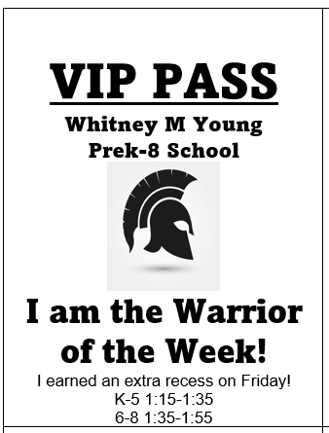

## Warrior of the Week Dates

Each Friday unless canceled by administration/or a school wide incentive is planned)

Prek-4 students will assemble in the gym from 1:15-1:35. Grades 4-8 will assemble in the gym between 1:35-1:55.

## Assembly Expectations

During the assembly, students will sit in their designated area. Teachers will monitor their students. If an assembly during a teacher’s planning time, the encore teacher will be responsible for the class. Students will be expected to stay in their seat, keep hands to yourself, remain at a voice level 0 when the speaker is talking, and stay respectful.

## Bookbag Policy

In an effort to ensure the safety of the building, its staff members, scholars and families, *no bookbags will be permitted in the classrooms*. The expectation is that after scholars enter the school, go through the metal detectors, and have their bookbags inspected, that the bookbags are either placed in their lockers or their cubbies.

For scholars in grades sixth through eight, they will have ample time to practice how to get into their lockers during the first two weeks of school. Additionally, lockers are not to be shared amongst scholars as there is plenty for each scholar to have their own assigned to them by their homeroom teacher. Scholars in the middle school grade level will have three minutes to transition between classes in which they can also go to their lockers before the bell rings. As we want to ensure that our scholars make it to classes on time, so they do not miss instruction, it is important that they use the time provided to ensure they know how to open their lockers. On a final note, Mr. McFarland’s office is no longer an option for scholars to place their materials in as they have their lockers to hold their items instead. Scholars may decorate the inside of their lockers with magnetic stickers, organizational items and small mirrors, but not permanent stickers as this is school property. Additionally, ladies can carry a small purse.

## Pink Raffle in Classrooms

Students can earn a pink raffle ticket each time they land on pink by the end of the day. Teachers will select a number of students by a random drawing and shared during your morning meeting.

(Possible prizes for raffles or whole class Incentives: Lunch with the teacher, Lunch with teacher and a buddy, No homework pass, First choice of classroom job, Bring a stuffed animal to school, Pajama Day pass, Prize from a prize box, Extra ipad time, Extra class Recess, Movie Day, Read aloud outside with a snack.)

## Community Class Jobs

In order to build community and ownership within the classroom, students in grades prek-8 should be assigned a classroom job for the week. Some of the jobs may include: Line Leader, Paper Passer, Lunch box holder, Cleaner, Trash Collector, Door Holder, Caboose, Light Helper, Secretary (answers phones with a script), Chair Pusher, Attendance Folder Helper (optional)

## School Wide Incentives/ Student Culture Celebrations

*(Tentative dates and activities/subject to change)*

Friday September 27 - Popsicle Day!

Thursday October 31 - Hall-o-Halloween!

Friday November 22- Fall Festival!

Friday December 20- Polar Express Day!

Friday January 31- Movie Day with Popcorn in Classrooms!

Thursday February 13- Friendship Dance (During School hours)

Friday March 21 - Minute to Win IT Competition!

Friday April 25- Ice Cream Social!

## End of Year Activities

*(Tentative dates/subject to change)*

Jr. Prom- Friday May 16

Pre Kindergarten Graduation- Tuesday May 20

Kindergarten Graduation- Wednesday May 21

8th Grade Promotion- Thursday May 22

Whitney Young Field Day- Friday May 23

## Other Important Dates

First Day of School for Students- Monday August 19

No School- Labor Day- Monday September 2

Open House- Thursday September 12 (6:00-8:00)- Early dismissal for students

No School- Fall Recess- Friday October 11

End of Quarter 1 Marking Period– Friday October 18

Picture Day- Tuesday November 19th

Parent Teacher Conferences (No school for students)- Tuesday October 29 12:30-7:00

Special Education Child Count- Thursday October 31

No school- Election Day- Tuesday November 5

No School- Veterans Day- Monday November 11

No School- Thanksgiving Break- Wednesday November 27- Friday November 29

End of Quarter 2 Marking Period- Friday December 20

No School Winter/Christmas Break- Monday December 23-Friday January 3

No School- MLK Day- Monday January 20

Parent Teacher Conferences- Wednesday February 5 (Early Release Day at 11:00)

Full Professional Development Day- Friday February 14 (No school for students)

No School- Presidents Day- Monday February 17

End of 3rd Quarter Marking Period- Friday March 14

No School- Spring Break- Monday March 24- Friday March 28

No School- Good Friday- Friday April 18

Parent Teacher Conferences -Wednesday April 23 (Early Release Day at 11:00)

No School- Memorial Day- Monday May 26

Last Day of School for Students- Thursday May 29

Last Day of School for Teachers- Friday May 30

## 

## Early Release Schedule

(This schedule is to be used when we have an Early Release Day, due to Parent Teacher Conferences)

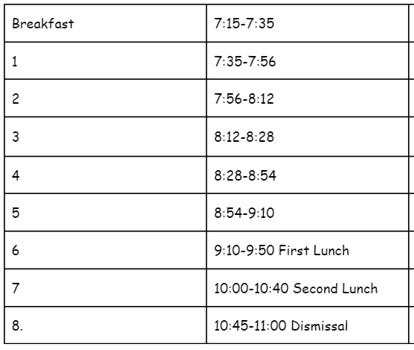

## Special Assemblies

Friday February 28- Black History Month Program

Friday May 2- Spring Concert

(Artwork from classes should be on display for both assemblies for parents to view)

## Morning Announcements

Bias and select middle school scholars will begin each morning with morning announcements at @7:45-8:00. Bias/student morning announcers will share a warm welcome, the date, the WY Warrior Creed, announcements, additional expectations for the day, and daily affirmations. On Fridays, the Warriors of the Week will be announced. If you would like to submit an announcement; place it in the announcement folder the day before by 2:00.

## FIELD TRIPS

Request your field trip through Allen to see if funding is available. (Information needed; date, location, Admission Fee, where the funding coming from?) Must be requested 12 days before your trip.)

Go into Food and Nutrition Services and request bagged lunches 10 work days in advance There are no exceptions.

Download field trip permission slip on the District’s Website. (Allen hard has copies if needed).

On the day of the trip provide a copy of the students attending the trip to Allen and take a list with you with contact information of each student.

Be sure to provide a plan for students who are not attending the trip. Provide the plan to Allen, Bias, and Dykstra. Also make sure students have supplies, works, and materials for the day.

Due to funding restrictions this year, we have decided to fairly distribute the funds for transportation evenly. Each grade band will be granted 3 field trips per year. Grade bands are: prek-k, 1-2, 3-5, 6-8.

# MASTER SCHEDULING

The master schedule will be sent in an excel format. Admin/UCC will determine the times for lunches and planning periods.

## Bell Schedule

* Doors open daily at 6:45 for staff
* Students eat breakfast 7:15-7:35
* Teacher report time: 7:25
* Para Report time 7:15
* 7:35-2:05

# ROLES AND RESPONSIBILITIES

## Paraprofessionals

* Responsibilities will be include breakfast duty for their students, lunch duty for their students, assisting in arrival procedure, and the dismissal procedure. Paras will assist with late pick-ups in the cafeteria until 3:30 or and all clear.

## Encore Teachers

* Prek-8th grade encores will take place in their encore rooms. Classes will travel to rooms at assigned times from the master schedule.
* Encore teachers must use the referral protocol and not send students back to class.

## Intervention Specialists

* Administrators need to work with liaisons and intervention specialists to ensure that the number of minutes requiring service are met (focus on SDI).
* Caseloads may be shifted by the special education liaison and administration based on enrollment.
* Updated reports are expected to be submitted to admin 2 days prior to a scheduled meeting

# HOMEWORK POLICY

In a continued effort to support our scholars and families in preparation for the end of the year state tests, scholars will have homework for grades K-8 Monday through Thursday . This homework may be paper and pencil based, instead of online. It will be turned in daily to the respective teacher and graded. To assist with this, it will be necessary for each family to have school-based supplies as well as an appropriate working space for scholars to complete their assignments at home. These assignments will be a reflection and a review of the material that has previously been covered in class to reinforce the skills. Each assignment should be completed independently and with minimal adult support. Homework can also be a family project or school/home connection.

.

# PROFESSIONAL DEVELOPMENT

* 50 minutes will take place each Tuesday from 2:10-3:00. Be sure to sign in at all staff developments so that you will earn your credits. A staff member will be assigned to collect the sign in sheet and submit it to the district.
* Opportunities for VPD (Voluntary Professional Development) will be given throughout the school year).
* During full day professional development, the principal must approve professional developments outside the building’s pd.

## WMY 50 Minute Meetings

*Planned by Building Leadership Team and UCC- 50 Minutes will take place every Tuesday. All staff, with the exception of paraprofessionals, are expected to attend)*

50 minutes will take place in the Verizon Lab from 2:10-3:00 every Tuesday

|  |  |  |  |
| --- | --- | --- | --- |
| **Internalizing Lessons**  **(1st Week)** | **Internalizing Lessons**  **(2nd Week)** | **Data Driven Instruction**  **(3rd Week)** | **Principal’s Choice (Committees/APT/AAP TDES)**  **(4th Week)** |
| N/A | August 13 | August 20 | August 27 |
| September 3 | September 10 | September 17 | September 24 |
| October 1 | October 8 | October 15 | October 22  (Conferences Oct 29) |
| No school November 5 | November 12 | November 19 | November 26 (TDES Quarter 1 PD) |
| December 3 | December 10 | December 17 (Staff Christmas Party) | December 24 (No 50 Min Winter Break) |
| January 7 | January 14 | January 21 | January 28 (TDES Quarter 2 PD) |
| February 4 | February 11 | February 17 | February 25 |
| March 4 | March 11 | March 18 (TDES Quarter 3 PD) | March 25 (No 100 Min- Spring Break) |
| April 1 | April 8 | April 15  April 22 | April 29 |
| May 6 | May 13 | May 20 (Closing Procedures) | May 27 (End of Year Celebration Reflection) |

## Internalizing Lessons

During the internalizing lesson sessions; K-2 will focus on structured Literacy and Into Reading. 3-5 will focus on Into Reading and module planning internalization. 6-8 will focus on unit planning based on scope and sequence. Each staff member must be prepared by bringing a teacher edition to the curriculum, the internalization lesson template, MAPS, and copy of the sequence.. Teachers must submit a copy to admin/MLT/ or reading structured specialist by the conclusion of the planning session OR complete an exit slip focused on next steps. All group discussions will take place in a designated location in the Verizon Lab. Teams will not go to separate classrooms.

## Data Driven Instruction

## The DDI sessions will be closely aligned to the TBT process in previous years. All team members must be prepared by providing and submitting the data for the team before the meeting. Each member must be prepared by bringing work samples to each meeting. We will begin on time and end on time. Each member will have one or more of the following jobs: facilitator, time keeper, or note taker. All group discussions will take place in a designated location in the Verizon Lab. Teams will not go to separate classrooms. Members must adhere to the following protocol:

## SEE IT- Unpack standards and analyze aligned assessment items

## NAME IT- Review student work samples to identify the skills gap

## DO IT- Create and enact (act out) a plan for reteaching

## Planning and DDI Teams

**K-2 Team: Gladin, Evans, Saunders, Lipscomb, McBee , Woody, Fountain (DDI based on AIMS Web)**

**3-5 Team: Roundtree, Perry, Smith, Bias 4-5: Kmitt, Sullivan, Kraska, Kresak (DDI baked on unit assessments)**

**6-8a Team: Moomaw, Shemo, Walker, Alexander, Dykstra (DDI based on unit assessments)**

**6-8b Team: Cummings, McFeely and Pope, Dykstra (DDI based on unit assessments)**

***(Principal Bias will oversee and check in on all teams)***

## 

## Teacher Professional Development Days

* Friday February 14 (full day PD, no school for students)

# COMMITTEES

The following committees will be held throughout the 2023-2024 school year:

# Academic Progress Committee

Focus on the academic goals in the AAP, progress monitoring, feedback to teachers, and reflection on next steps.

Events to consider (Awards ceremonies, Presenting data results to staff and district for mid year reviews, we will meet each month)

## Attendance Committee

Focus on the progress monitoring of attendance goals. Make calls and give support to families whose students are approaching chronic absences.

Events to consider (Individual or class incentives/prizes for attendance gains or improvement)

# 

# Family and Community Engagement Committee

Focus on networking with families to keep them engaged in scholars and school events. Reach out to the community partners that will add opportunities and resources to the school.

Events to Consider (Monthly Warrior Roundtables, Community fairs ,Literacy Nights)

# Student Culture Committee

Focus on keeping a high engagement for scholars to stay excited about school, learning, and friendships.

Events to consider (School Wide Incentives, Dances, parties, Field day)

## Staff Sunshine Committee

Focus on maintaining a positive climate within the staff by planning fun activities to build relationships. The committee will also recognize transitions amongst staff including birthdays, marriages, deaths of a loved one. Teachers will pay dues in order to participate in events.

Events to Consider (Staff celebrations, gifts to staff, off campus gatherings, recognition of perfect attendance)

# 

# STAFF CALL OFFS

You must call the sub-center (216-920-0905) or put in your absence on-line by the start of the school day, per the sub-center. If you fail to report your absence by 6 am or at all for the day that you're going to be out, you will be considered "absent without leave" until a reasonable excuse and or explanation is given to Principal Bias. (Be sure to obtain a code for the sub center.)

# CUSTODIAL REQUESTS

* If teachers are in need of PPE OR other cleaning supplies, submit email request to the custodian- Justin Steward and copy the principal for the items they are responsible for (e.g. sanitizer, soap, paper towels, disinfectant spray)
* Use the following for the title of the email: “PPE Request Room ____”
* Steward will have 24 hours to fulfill the request and send a receipt acknowledging the materials were delivered.
* CC Bias and Lipscomb on requests

# 

**WHITNEY YOUNG ACADEMIC PLAYBOOK**



# TDES SCHEDULE 2024/2025

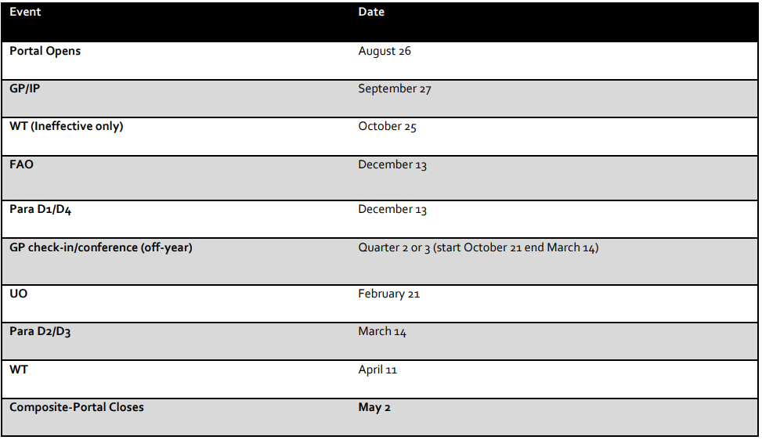

# 

# 

# STUDENT MATERIALS

## 

## Student Devices/Technology

* Since the District has achieved its goal of a 1:1 student-to-device ratio, there are limited situations where a student will need access to a second device while participating in in-person learning.
* Students in grades PreK - K will be provided access to iPad carts by Early Childhood.
* Schools will receive computer charging carts in case a student device does require charging.
* Schools will receive additional devices to serve as loaners when students leave their devices at home or need charging. Loaner devices should be maintained at the school and not allowed to be taken home by students.
* Requests for additional devices or replacement devices will continue to be through the online Smartsheet application until further notice.
* If any classroom technology is discovered to be not working, it should be report to the IT Department by contacting the Service Desk (838-0440) or submitting an online service request at servicedelivery.clevelandmetroschools.org.
* Devices issued to students will need to be protected as much as possible. Schools will receive backpacks to provide to students before their return to in person learning. Schools will receive advanced notice of the delivery of their backpacks.
* Students can receive a loaner device from McFarland
* Supply list was sent home by mail and posted on the website.

## 

## Student Supplies

* Create a dedicated set of learning materials and resources for each student if enough materials are available (e.g. individual pouches or bins for supplies)
* If enough resources are not available, materials should be wiped down by students before sharing with the next set of students.
* It is recommended to have a dedicated space (e.g. Basket or plastic bin) for books that can separate recently used books from available books
* Desks and high-touch areas are to be sprayed and wiped-down at the close of each day (can be completed by students, however keep in mind that some students may have sensitive skin/allergies)

# PERSONALIZED LEARNING

## Definition of the Model

This model is characterized by flexible, anytime/everywhere learning; redefining the teacher’s role and expanding the “teaching” meaning; authentic, project-based learning; student-driven learning paths, and; mastery/competency-based progression and pacing. The premise of the theory rests on the assumption that, given the ability to self-direct their learning, students will make greater gains in achievement due to increased interest and customization. (Directly from AAP)

## Teacher Commitments- PL

- Support the school's vision, mission and Design Option.

- Engage in professional development focused on the school's redesign.

- Engage in grade level and/or cross grade level team collaboration and planning.

- Balance direct instruction strategically with personalized learning and teaching methods.

- Use a range of strategies such as formative assessments to reach diverse students and create environments that support differentiated teaching and learning.

- Align technologies with content and pedagogy and develop the ability to creatively use technologies to meet learning needs. (Directly from AAP)

## Teacher Supports- PL

-The school will have a four year phase-in schedule to allow design options to be implemented and grow.

- Provided professional development and in school coaching in support of developing and enhancing teacher commitments.

- Provide opportunities for teachers to visit classrooms / schools.

- District walkthroughs will be implemented throughout the school year using the Look For Model from the approved AAP

# Grading Submission Timeline

The district and UCC have agreed upon a timeline for inputting grades into Powerschool. Parents and families will have access to MyPowerhub and they will be checking grades online. Bias and Dykstra will be checking to see if grades have been submitted in each subject area on near/on the dates listed below:

|  |  |  |  |
| --- | --- | --- | --- |
| **Quarters** | **Weeks** | **Date** | **Time** |
| **Quarter 1** | **3** | **Monday, September 16th** | **7:30am** |
| **Quarter 1** | **6** | **Monday, October 7th** | **7:30am** |
| **Quarter 1 (final week of Q1)** | **9** | **Monday, October 28th** | **N/A** |
| **Quarter 2** | **3** | **Monday, November 18th** | **7:30am** |
| **Quarter 2** | **6** | **Monday, December 9th** | **7:30am** |
| **Quarter 2 (final week of Q2)** | **9** | **Monday, January 13th** | **7:30am** |
| **Quarter 3** | **3** | **Monday, February 3rd** | **7:30am** |
| **Quarter 3** | **6** | **Monday, February 24th** | **7:30am** |
| **Quarter 3 (final week of Q3)** | **9** | **Monday, March 31st** | **N/A** |
| **Quarter 4** | **3** | **Monday, April 14th** | **7:30am** |
| **Quarter 4** | **6** | **Monday, May 5th** | **7:30am** |
| **Quarter 4 (final week of Q4)** | **9** | **Thursday, May 29th** | **N/A** |

**Grading Scale**

The UCC and district have agreed upon a grading scale that will be used for all of the schools in the district.

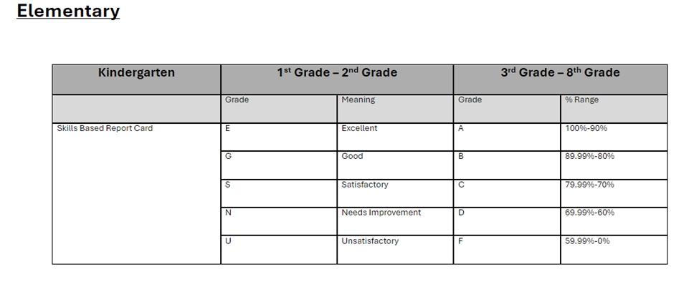

# TESTING CALENDAR

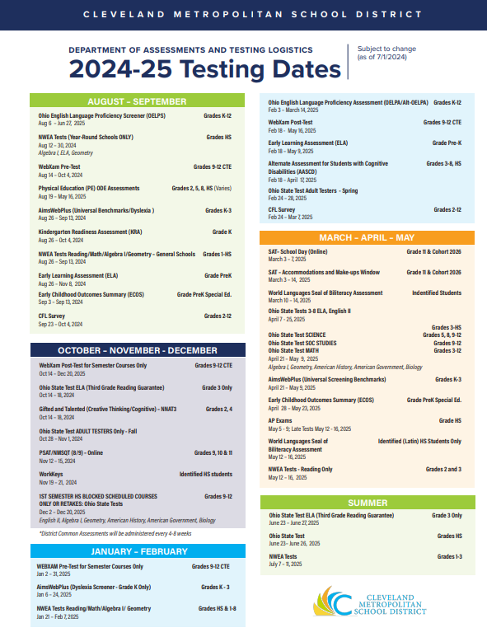

# 

# WHITNEY M YOUNG FIRST RESPONDERS

|  |  |  |  |  |  |  |  |  |
| --- | --- | --- | --- | --- | --- | --- | --- | --- |
| Academics | | | |  | Technology | | | |
| **Topic** | **First** | **Second** | **Third** |  | **Topic** | **First** | **Second** | **Third** |
| SST Referrals | Nicole Dykstra | Nicole Dykstra | Cory Vaughn / Julie Wojcik |  | Clever Logins | Frederick McFarland | Ryan McFeely | Christopher Kraska |
| SST Questions | Nicole Dykstra | Nicole Dykstra | Cory Vaughn / Julie Wojcik |  | Family Tech Support | 838-0440 | Ryan McFeely | Christoper  Kraska |
| Special Ed Questions | Julie Wojcik | Kimberly Shemo | Nicole Dykstra |  | Teacher Tech Support | 838-0440 | Frederick McFarland |  |
| IEP & ETR Meetings | Nicole Dykstra | Carlisha Bias | N/A  *If neither admin can attend, this will need to be rescheduled by the IS* |  | Schoology Support |  |  |  |
| IEP & ETR Questions | Kimberly Shemo | Nicole Dykstra | Julie Wojcik/Cory Vaughn |  | Family Tech Support |  |  |  |
| 504 Plans | Nicole Dykstra | Julie Wojcik | Cory Vaughn |  |  |  |  |  |
| Testing | Matthew Pope | Nicole Dykstra | Carlisha Bias |  |  |  |  |  |
| K-3 Literacy Questions | Virgina Kresak | Carlisha Bias | Arlisa Fountain |  |  |  |  |  |
| Structured Literacy/Into Reading and Into Literature and DDL | Arlisa Fountain | Nicole Dykstra | Arlisa Fountain |  |  |  |  |  |

|  |  |  |  |  |  |  |  |  |
| --- | --- | --- | --- | --- | --- | --- | --- | --- |
| Culture | | | |  | Logistics | | | |
| **Topic** | **First** | **Second** | **Third** |  | **Topic** | **First** | **Second** | **Third** |
| Discipline | Frederick McFarland | Nicole Dykstra | Carlisha Bias |  | Timecards | Stefanie Allen | Carlisha Bias |  |
| Referrals | Frederick McFarland | Nicole Dykstra | Carlisha Bias |  | Payroll | Stefanie Allen | Carlisha Bias |  |
| Parent Concerns | Frederick McFarland | Nicole Dykstra | Carlisha Bias |  | Field Trips | Stefanie Allen | Carlisha Bias |  |
| SEL Support | Syretta Taylor | Yolanda Conner |  |  | Student Schedules | Stefanie Allen | Carlisha Bias |  |
| Say Yes Support | Nicole Washington |  |  |  | Subcenter | Stefanie Allen | Carlisha Bias |  |
| Project Act | Lisa Renee Black |  |  |  | Order Status | Stefanie Allen | Carlisha Bias |  |
| Life Solutions | Deborah Watson |  |  |  | Student Attendance | Stefanie Allen | Carlisha Bias |  |
|  |  |  |  |  | Attendance Liaison | Jennifer Jones |  |  |

# CURRICULUM

**k-3rd**

HMH Into Reading

HMH Structured Reading

Zearn

Sound Walls

Mystery Science

I Ready

Amira Reading

Eureka

HMH Into Science/Social Studies

**3rd- 4th Grade**

Into Reading

Zearn

Sound Walls

I Ready

Amira Reading

Eureka/ Into Math

HMH Into Science/Social Studies

**5th-8th**

HMH Into Literature

Zearn

VILS

I Ready

Eureka/ Into Math

HMH Into Science/Social Studies

Special Education

Unique Learning

**WE ARE THE WARRIORS!!!**

